Type or paste the title of the work here

**by**  
**[Firstname Lastname]**

[Previous degree, institution, YEAR]  
[Previous degree, institution, YEAR – if more than one list in descending order]

[Thesis/Project/Extended Essays] Submitted in Partial Fulfillment of the  
Requirements for the Degree of  
[Master of…/Doctor of…]

in the  
[School/Department of …]  
[Faculty of …]

© [Firstname Lastname] YEAR  
SIMON FRASER UNIVERSITY  
[Term YEAR]

Copyright in this work rests with the author. Please ensure that any reproduction   
or re-use is done in accordance with the relevant national copyright legislation.

Declaration of Committee

|  |  |  |
| --- | --- | --- |
| **Name:** | **[Firstname Lastname]** | |
| **Degree:** | **[Master of …/Doctor of …]** | |
| **Thesis title:** | **Type or paste the title of the work here** | |
| **Committee:** | **Chair:** | [Firstname Lastname] [Academic Role, Academic Unit] |
|  | **[Firstname Lastname]** Supervisor [Academic Role, Academic Unit] | |
|  | **[Firstname Lastname]** Committee Member [Academic Role, Academic Unit] | |
|  | **[Firstname Lastname]** Committee Member [Academic Role, Academic Unit] | |
|  | **[Firstname Lastname]** Committee Member [Academic Role, Academic Unit] | |
|  | **[Firstname Lastname]** Committee Member [Academic Role, Academic Unit] | |
|  | **[Firstname Lastname]** Examiner [Academic Role, Academic Unit] | |
|  | **[Firstname Lastname]** External Examiner  [Academic or Professional Role, Academic Unit] [Institution] | |

Please review the Declaration of Committee page instructions on the library’s thesis website before completing this page:   
[**https://www.lib.sfu.ca/help/publish/thesis/format/declaration-committee**](https://www.lib.sfu.ca/help/publish/thesis/format/declaration-committee)

Remember to delete this note before submission.

Ethics Statement

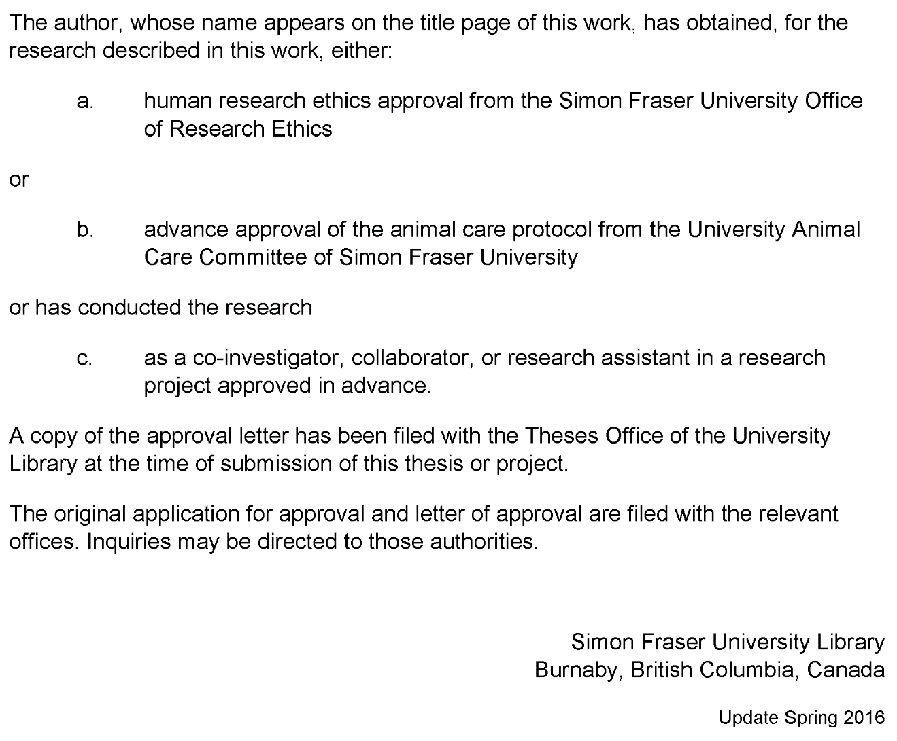

This page must appear as p. iii if your research required ethics approval. Remember to delete this note before submission.

If an ethics exemption was granted, this page must be removed.

If ethics approval was not required, this page must be removed.

Remember to update the Table of Contents after removing this page.

Abstract

Fishery data visualization plays important role for companies in countries with developed fishery infrastructure

In my paper I am going to show trends, anomalies, year-by-year comparison (drill-down) of fishing catches and money value.

Showing correlation between these two parameters for each Canada province and fish species is a main part of the work.

This will provide a user-friendly way to show all necessary data for non-domain expert users in a web browser, using the novel js library amCharts.

Tool will help users to see/identify issues with fish amounts in certain regions as well as help fishery managers to add or remove restrictions on fish quotas etc. The tool can help to answer questions like “Which species is being caught and how much of it?” or “Is the biological diversity of the fishery threatened?”

Having it in a web browser is very handy for users because they don’t have to install software on their computers which may not be compatible with OS.  
This will be a highly accessible multi platform tool which will help to analyze table data much quicker and will give some answers for users who are interested in the fishery domain.

**Keywords**: fishery; web-interface; visualization; online platform

Dedication

This is an optional page. Use your choice of paragraph style for text on this page (**1_Para_FlushLeft** shown here).

To hide the heading at the top of this page, select the text and change the text colour to white.

Acknowledgements

This is an optional page. Use your choice of paragraph style for text on this page (**1_Para** shown here).

Table of Contents

Declaration of Committee ii

Ethics Statement iii

Abstract iv

Dedication v

Acknowledgements vi

Table of Contents vii

List of Tables viii

List of Figures ix

List of Acronyms x

Glossary xi

Preface/Executive Summary/Image xii

Chapter 1. Introduction 1

Chapter 2. Related Work 2

2.1. Role of the Fishery Visualization 2

2.2. Marine Environmental Management 2

2.3. Approaches to Visualization 5

Chapter 3. Design and Use Cases 6

Chapter 4. Implementation (Tool Overview) 9

Chapter 5. Conclusions and Future Work 10

References 11

Appendix A. An Example of an Appendix 12

List of Tables

**No table of figures entries found.**

Use References>Insert Caption to create caption labels and numbers. Right-click on the text above and select Update Field to update this list. See the Thesis Template Instructions for information on creating tables, figures, and captions.

Remember to delete this note before submission.

If there are no tables in the document, remove this page.

List of Figures

**No table of figures entries found.**

Use References>Insert Caption to create caption labels and numbers. Right-click on the text above and select Update Field to update this list. See the Thesis Template Instructions for information on creating tables, figures, and captions.

Remember to delete this note before submission.

If there are no figures in the document, remove this page.

List of Acronyms

|  |  |
| --- | --- |
| SFU | Simon Fraser University |
| LAC | Library and Archives Canada |
|  | This is an optional page and can be removed if not used. |
|  | Use one table row for each item to allow sorting using Word’s table tools. |
|  | Apply the style **1_Para_NoSpace** to table rows as shown here. |
|  |  |
|  |  |

Glossary

|  |  |
| --- | --- |
| Thesis | An extended research paper that is part of the final exam process for a graduate degree. The document may also be classified as a project or collection of extended essays. |
| Glossary | An alphabetical list of key terms |
|  | This is an optional page and can be removed if not used. |
|  | Use one table row for each item to allow sorting using Word’s table tools. |
|  | Apply the style **1_Para_NoSpace** to table rows as shown here. |
|  |  |

Preface/Executive Summary/Image

This page can be used for a Preface, Executive Summary, or introductory image. This is an optional page and can be deleted if not used.

To hide the heading at the top of this page – e.g., if using an introductory image – select the text and change the text colour to white.

Do not delete the section break that follows this paragraph. If the section break is not visible, turn on non-printing characters using the Show/Hide icon (¶) on the Home ribbon.

# Introduction

Main motivation for my research is to help users to make their work faster and more productive. I’m working on a software development company right now and sometimes we have requests not only for giving access to raw table data but for data processing, analysis and making some reports.

Of course, digging into raw data might give you results that you expect, but it usually takes a lot of time if you have a big amount of data or are not very familiar with computer software.

Visual data representation plays a very important role in data analysis. It can condense huge amounts of data into several plots and labels, giving you information about trends, it is easier to compare pictures than data rows for sure.

My research will help people who are domain experts but not very familiar with data analysis tools. The tool can help fishery management with regulation of fishery catching in certain Canadian provinces, and will help to decide which policies or fishing quotas for specific fish types should be applied.

# Related Work

## Role of the Fishery Visualization

Visualization is a very important tool for decision support in fisheries information systems. It can give a person, who is working with fishery information more insights about data. It usually saves time for making correct decisions about business logic of the fishing company, because it is easier to see trends, outliers etc. while using charts and interactive diagrams rather than just looking through a spreadsheet, which may be located even in different files.

There are different groups of users in the fishery domain. Papers, discussed in this chapter are oriented mostly for fishery management, but written in a way that it is not easy to understand completely if you are not a data analyst or/and experienced computer user.

Main goal of the work is to create a tool which will be easily accessible for both types of users: data scientists and fishery management which are making decisions based on conclusions of the data presented in a tool.

## Marine Environmental Management

FishCAM2000 (FC) [1] is a computer-based integrated information system for fisheries management and marine environmental monitoring. It illustrates a visualization of the fishery activity over the same spatial area of interest for a special type of fish etc. It has a simple and user friendly interface implemented in Windows Forms. Figure 2.1.1 below shows output after user passes 7 screens of settings of the query wizard. It looks like there are too many steps for a user to get a result, but it was a requirement for the tool to be as generic as possible. Good point is that it presents complex geo data on the map instead of the data table which is a huge time saving for users to understand the query output.



Figure 2.1.1 [1]

Next work which is to mention is a tool which gets and analyzes data which is directly coming from vessels [2]. It is also geographical data and the amount of fish caught by a particular vessel in a certain region. Authors show not only geographical spread of fish, but they also have year-to-year comparison charts (Figure 2.2.2).

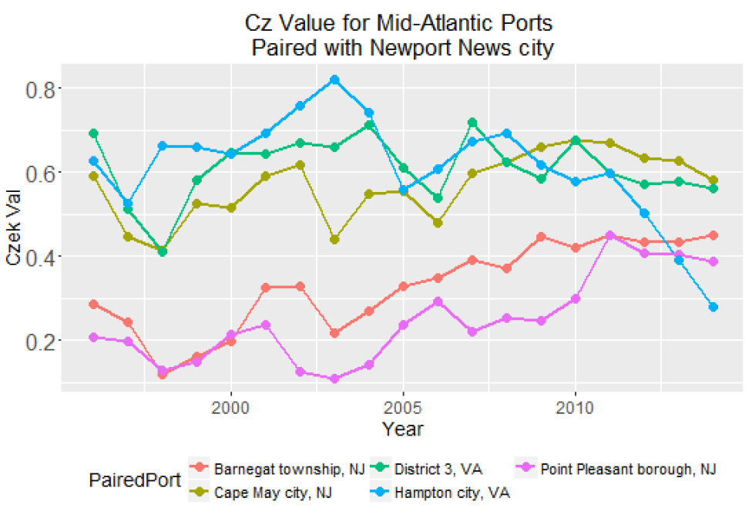

Figure 2.2.2 [2]

Whereas the works we have discussed so far focussed on the visualization of geographical and vessel related data, the work of da Silva, Charles Fulcher [6] allows the investigation of land-sea connections. It shows to the reader human impact on the sea from land and vice versa. The maps show the connection between vessels and ports and also depict the distribution of gear types used in different regions etc. All that is done with descriptive labels, lines and appropriate legends which any person can be easily understood.

The work of Barris about the state of the salmon [7] provides a good basis for a platform to support analysis and interaction for fishery data through visualization. It uses DFO data related to salmon in BC rivers and the author discussed and tried to produce visualizations for questions that marine experts asked him to solve. In particular, in his work he says that all data sources for DFO are decentralized and there is practically no interface which allows user to analyze data. So he combined several data sources and produced visualizations which answers questions about the state of salmon in Canadian rivers.

## Approaches to Visualization

The paper with time series prediction on stocks [5] mostly shows the difference between prediction algorithms, but the visualization part requires special attention. Authors used distinct color coding to show results, there is no extra information on the chart which distracts or confuses readers.

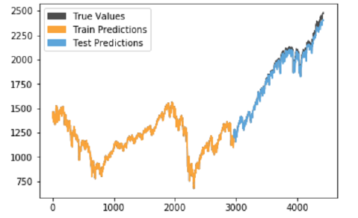

Figure 2.3.1

IDMVis [8]: a visualization tool for a patient with diabetes which shows multidimensional interrelated data during the day. IDMVis includes a novel technique for folding and aligning records by dual sentinel events and scaling the intermediate timeline. It was designed to help doctors to track the state of important parameters of patients and to detect anomalies. After that it can be used as a decision support tool for treatment of diabetes. Design decisions were evaluated by six clinicians.

Papers discussed in this subsection are mostly explaining one visualization technique, but Sofia Semikina in her thesis work Stress Data Visualization compares methods of visualizing the same data in various amount of charts and diagrams of different types. She uses bar charts, line charts, pie charts, spiral charts. There is also user study involved in her work which shows in the end which visualization particular users understand better.

# Design and Use Cases

## Importance of Fishery Visualization

Ability to see yearly correlation is an important question for marine scientists, biologists and businesses which relay on a specific fish type.

According to the articles below people are more and more concerned about the state of the fish in the world ocean.

Cited: Most existing analyses suggest overfishing is increasing, and there is widespread concern that fish stocks are decreasing throughout most of the world.

https://www.pnas.org/content/117/4/2218

Cited:Fishing companies—businesses that catch fish or other seafood in the wild—will play a major role in sustaining food security and supporting fishing communities. But in their quest to capture enough fish to satisfy soaring demand, they are exerting unprecedented pressure on marine and freshwater ecosystems. It now takes five times the effort (in kilowatt-hours) to catch the same amount of fish as it did in 1950, because the targeted species are now in scarce supply.

https://www.mckinsey.com/industries/agriculture/our-insights/precision-fisheries-navigating-a-sea-of-troubles-with-advanced-analytics

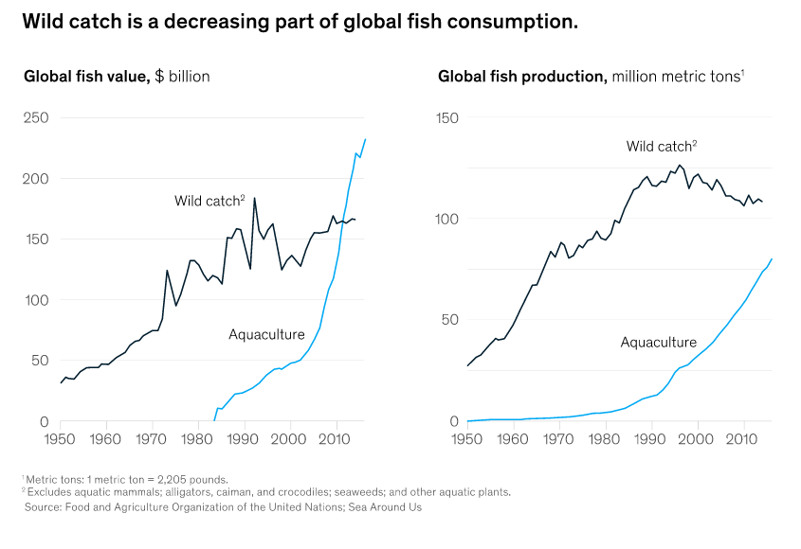

## Data Source and Visualization Motivation

Data source for the visualization is taken from DFO Canada website for provincial seafisheries.

Format: Data tables provide the volume and value of seafisheries landings. Data is organized by species-groups, by main species and by province.

Period covered: Data is available from 1990 to 2018 year before the current fishing season, data prior to 1990 is available upon request.

Sources: Data collected by DFO regional offices.

Data is separated yearly (one Microsoft Excel file for each year) and grouped inside by Canadian provinces for each fish type. In total this dataset consists of 56 files (28 for fish amount in tonnes and 28 for fish total value in thousand of Canadian dollars.

Analysis of the data presented in such format may take significant amount of time. For example, it is hard to see trends, how values change through the years, as well as comparing data for different provinces and fish type. Another thing which is hard to capture is correlation between price and quantities of a specific types of fish for a certain period.

The tool itself and it’s implementation will be discussed in Chapter 4, however, it is worth mentioning that it is developed for people who may not be data scientists. The main goal is to make it usable for people with average knowledge about computers. It also will not require any installation steps, because it is a web application which can be accessible just by typing url in any of the modern browsers. Another improvement is that tool will allow user to select range, provinces and any fish type from dropdowns, zoom into details etc. This type of UI experience if not available if it is done through Excel charts or Python library PyPlot. Visualizations in these cases are static and should be re-rendered if some parameters of visualization are changed. Also it requires advanced knowledge of Microsoft Excel or programming.

## Problem Set

### Problem 1 Showing the Correlation Between Fish Amount and Price in Time for Different Provinces and Fish Types

### Problem 2 Scatter Plot for Paired Time Series (Fish Amount and Price)

More description will be here….

# Implementation (Tool Overview)

The datasource comes from DFO (Fisheries and Oceans Canada). It is about fishing amount catches and money profit for years from 1990 until 2018.

I am creating a visualization tool to help people to understand / analyze table data in a more suitable format as chats, comparison diagrams etc.

The tool itself is implemented in typescript (wrapper for JavaScript) from Microsoft. Frontend framework angular 10 which is one of the most powerful and highly used web engines in the world. Back end is not needed for now as it is a test project. If the data source is changed there will be minimum code modifications to get / process data.

# Conclusions and Future Work

Bringing different datasources

References

[1] Visualization for fisheries management from a spatiotemporal perspective.

Z*. Kemp and G. Meaden, 2002*

[2] Visualizing Fishing Data as Rasters.

*Sharon Benjamin, Min-Yang Lee, Geret DePiper, 2018*

[3] Spatial and Temporal Differences in the Reproductive Traits of Skipjack Tuna.

*Hiroshi Ashida, 2020*

[4] Evaluation of a US West Coast Groundfish Habitat Conservation Regulation via Analysis of Spatial and Temporal Patterns of Trawl Fishing Effort.

*Marlene A. Bellman, Scott A. Heppell, Chris Goldfinger, 2005*

[5] Time Series Prediction: Predicting Stock Price.

*Aaron Elliot, Cheng Hua Hsu, 2017*

[6] Using GIS to Visualize Land/Sea Connections: Case Study - NE Herring Fishery.

*Patricia Pinto da Silva, Charles Fulcher, 2007*

[7] The State of the Salmon.

*Michael Barrus, 2017*

[8] IDMVis: Temporal Event Sequence Visualization for Type 1 Diabetes Treatment Decision Support.

[*Yixuan Zhang*](https://pubmed.ncbi.nlm.nih.gov/?term=Zhang+Y&cauthor_id=30136981)*,*[*Kartik Chanana*](https://pubmed.ncbi.nlm.nih.gov/?term=Chanana+K&cauthor_id=30136981)*,*[*Cody Dunne*](https://pubmed.ncbi.nlm.nih.gov/?term=Dunne+C&cauthor_id=30136981)*, 2018*

[9] Stress Data Visualization.

*Sofia Semikina, 2014*

Appendix A.  
  
An Example of an Appendix